
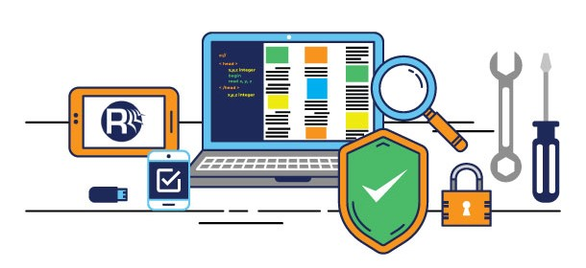

Software Testing
Aidan Forde | Software Testing | Test plan
Table of Contents

1.0 INTRODUCTION

2.0 OBJECTIVES AND TASKS

2.1 Objectives

2.2 Tasks

3.0 SCOPE

4.0 Testing Strategy

4.1 Unit Testing

4.2 System and Integration Testing

4.3 Performance and Stress Testing

4.4 User Acceptance Testing

4.5 Batch Testing

4.6 Automated Regression Testing

4.7 installing Testing

5.0 Test Schedule

6.0 Control Procedures

7.0 Features to Be Tested

8.0 Features Not to Be Tested

9.0 recourse

10.0 Schedules

11.0 Risks/Assumptions

12.0 Tools

1.0 INTRODUCTION

The software test will ensure that pixel wizard is free from input errors and all the game logic will function as intended. Once the player has opened the game, they will be presented with three options: ‘Play’, ‘Settings’, and ‘Exit Game’. Selecting ‘Play’ will take the player into the game and load the first level. The game will start immediately. From here, the player can progress through the level and once completed and once completed, the next level will load. At the start of the first level, text will appear on-screen informing the player of the control screen. The game will feature at least three levels, with each increasing in difficulty. This could range from having more and more enemies in the progressive levels, enemies having more health, the player character having less enemies, etc. Once the player has completed all the levels, the player will be presented with the option to either start again from the first level or quit the game. If the player chooses ‘Settings’ instead, they can instead adjust the sound level or music level. ‘Exit Game’ will close the game. Once inside the game, the player can pause the game at any time. From here, they can access a number of options: resume the game, access settings, restart the level, or exit the game.

2.0 Objectives and Tasks

2.1 Objectives
The objective of the test is to verify the functionality of ‘The Pixel Wizard’ and that the game works according to the specifications we will have to look for

- Bug Detection. ...
- User Satisfaction. ...
- Software quality and reliability

2.2Tasks

Perform Unit Testing
- Installation Testing
- Perform System Integration Testing
- Perform Performance and Stress Testing
- Perform User Acceptance Testing
- Perform Automated Regression Testing
- Perform Beta Testing Participants

3.0 Scope

Each type of testing is to be carried out within a 3 month period. The with the focus is so that the play through testing and functionality testing/feature testing phases are carried out specifically, however as long as these types of tests are covered as much as possible soak testing can be carried out. Extra testing will much more of the project and lead to a better carried out test plan to ensure quality is assured for the developers. Testing is limited to a lack of console testers within the company, to tackle this issue we will be using a third party compliance tester and also a third party hardware compatibility tester to help to complete the testing phase more efficiently. The hardware compatibility tester is to provide more efficient overall testing for localization testing, which will lighten the work load and in house testers can focus on testing assigned by the matrix.

Game play specs given by the pixel wizard
Game Components

Front End The game will have three options on start-up: ‘Play’, ‘Settings’, and ‘Exit Game’. Selecting ‘Play’ will take the player into the game and the player will begin at Level Settings’ will let the player to edit game settings, like sound level and music level. ‘Exit Game’ will quit the application’.

- In-Game Menus The game will have a number of options when the game is paused The player will be able to resume the game, access settings, restart the level, and exit the game. The player can resume the game by selecting the option or pressing the button for pausing/resuming the game. The player can view the settings and can adjust the sound level and music level

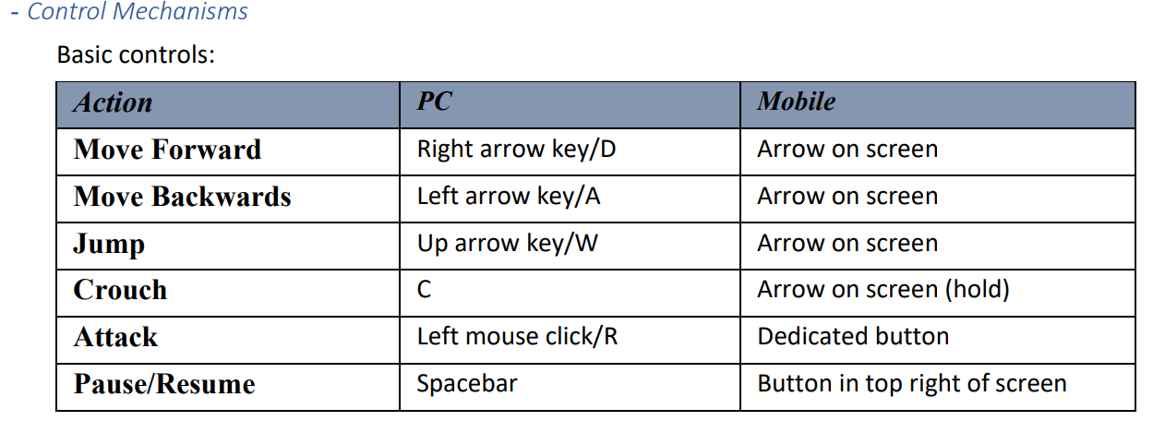

4.0Testing Strategy

4.1 Unit testing
Unit testing is a software testing method by which individual units of source code, sets of one or more computer program modules together with associated control data, usage procedures, and operating procedures, are tested to determine whether they are fit for use i.e. white box testing

Participants Bill gates and Martin Luther King

Bill tasked will writing up the test case. Bill and martin will be will be testing the other all movement of wizard with in the game so that it works with mobile devices and pc platforms. Every part of the game will have to tested at each stage to avoid bugs and glitches unit testing has to be done before moving on other stages of the testing.

4.2 System integration testing
System Integration Testing is a type of software testing carried out in an integrated hardware and software environment to verify the behavior of the complete system. It is testing conducted on a complete, integrated system to evaluate the system's compliance with its specified requirements big bang is an example of this it will test the overall game

Participants John F. Kennedy and Marilyn Monroe

System Integration Testing will be testing the overall system this will show the overall health of the system and will show problems found at an early stage and will not add a delay John F. Kennedy and Marilyn Monroe will be in charge of writing the cases

4.3 Performance and Stress Testing

Performance testing is carried out to check the system's performance under varying loads. Stress testing is carried out to check the behavior of the system under the sudden increased load. It contains load and stress testing as components.

Participants Winston Churchill and Charles Darwin

John and Marilyn will be checking the max performance of the system trying to overload the system to see how it reacts to this. Charles will be writing the test cases the control menu will be also tested to see how long it takes to execute once it is triggered.

4.4 Installation Testing

This is the first test to be run on a build this we done by lead tester Patrick because it is critical Testing will be carried out on every game and run on all platforms. Instructions for testing are as follows

• install the game on the system.
• If the game boots, it has passed.
• Try to manually boot the game,

if it does not boot then it has failed the test. So long as the game passes the installation tests, acceptance tests can then be carried out on the title.

4.5 Acceptance Testing

Acceptance tests are done to check is the game is stable enough to be completely tested in Quality assurance Acceptance testing is to test each section of the game is functioning
correctly,

The acceptance test is failed if the following occurs

- Failure to properly load or execute
- An excessive number of crashes, choppy video or sound or excessive graphical problems.
- Test all sound plays does not play correctly.
- Test all video plays does not play correctly
- Test do all menus loads correctly

4.6 Automated Regression Testing
Regression testing is re-running functional and non-functional tests to ensure that previously As regression test suites tend to grow with each found defect, test automation is frequently involved.

Participants
James brown

James brown will be re-running functional and non-functional tests to ensure that previously test cases are right automated testing is cheaper faster and more reliable and with regression testing human error is not a factor with this either

Test Schedule
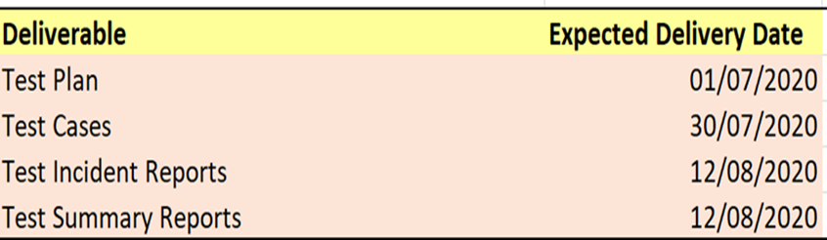

Control Procedures

Problem reporting

Bug reporting has to be carried out strict guideline meaning that all bug must be reported so that delays will not appear at later stages of the devolvement which could cause delays when a problem or bug is found it will have to recorded on problem form sheet so it can be dealt with in a timely manner and with severity factor number noted

- S1 - Critical: This means the defect is a show stopper with high potential damages and has no workaround to avoid the defect.

- S2 - Serious: This means that some major functionalities of the applications are either missing or do not work and there is no workaround

- S3 - Normal: This means that some major functionality do not work, but, a workaround exists to be used as a temporary solution

- S4 - Cosmetic / Enhancement: This means that the failure causes inconvenience and annoyance

- S5 - Suggestion: This is not normally a defect and a suggestion to improve a functionality.

Change Requests

During a project, this can happen when a client wants to change or alter the agreed upon deliverables these must be signed off by the project manager no changes can be made tom pixel wizard without written go head for the changes

Features to be tested

These are the main components of the game and must be tested in order for the game to run and to be functional.

- Front end menu
- In Game menu
- Game Controls
- Audio Settings
- Jump
- Health bar script
- Audio script
- Crouch
- Move backwards
- Audio scripts
- Respawn player
- Respawn enemy’s
- Save game
- Load game
- Audio setting
- Exit game

Features not to be tested

- Saving and loading level system
- File deletion system
- Loading time
- Network connectivity
- Battery Consumption

Resources /roles and responsibility

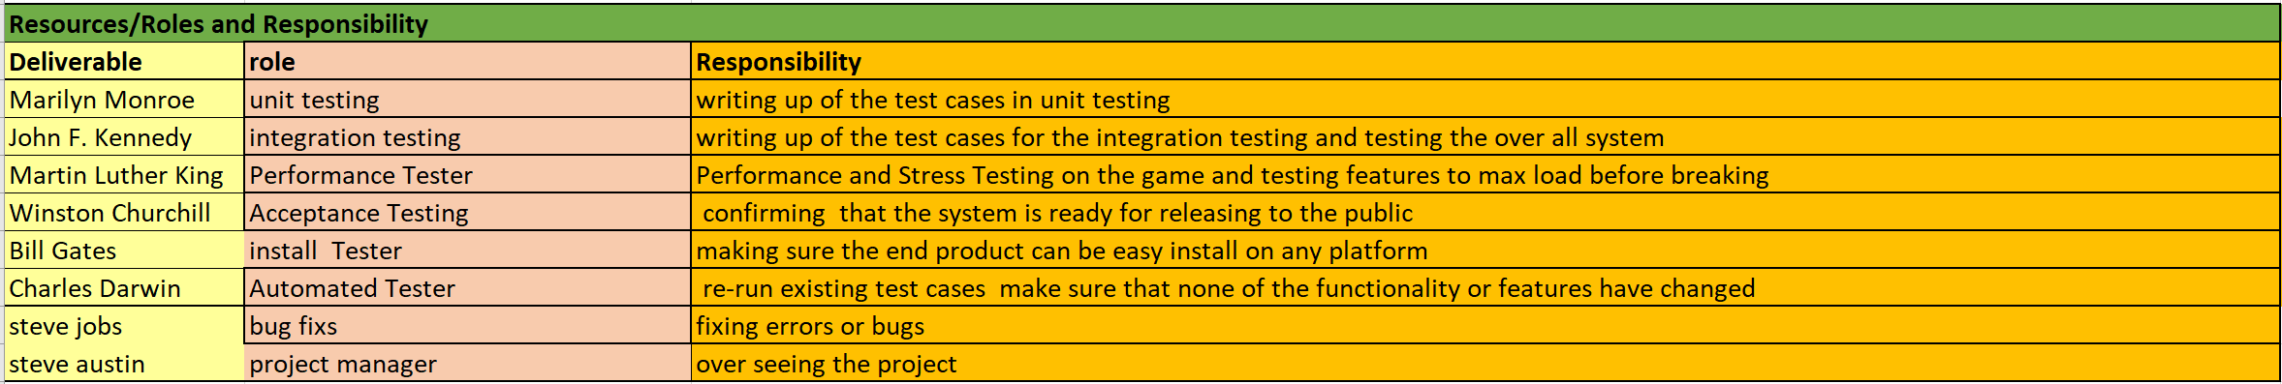

Risks/Assumptions
Risk | Solutions
Budget Risk  - Wrong budget estimation.  - Cost overruns  - Project scope expansion | Make sure the budget will accommodate over spend and wrong budget by setting a higher budget than what is needed
Technical Risks  Technical risks generally lead to failure of functionality and performance.  Causes of Technical Risks are  - Continuous changing requirements  - The product is complex to implement.  - Hardware or corruption  - Data loss | - Set a date that’s changes have to be submitted by  - Setting the level of complex at the early stage so not to run into this at a late stage  - Have spare computers in case of hardware failure  - Backup each day to a cloud sever
Programmatic Risks:  These are the external risks beyond the operational limits. These are all uncertain risks are outside the control of the program. These external events can be:  - Running out of the fund.  - Changing customer product strategy and priority | Have a plan in place for extra need funds if needed
Insufficient Testers | Hire outside testers

Tools

Test Management tools

Functional Testing Tools

Selenium is a testing framework to perform web application testing across various browsers and platforms like Windows, Mac, and Linux. Selenium helps the testers to write tests in various programming languages like Java, PHP, C#, Python, Groovy, Ruby, and Perl. It offers record and playback features to write tests without learning Selenium IDE

Load testing Tools
J-meter
The Apache JMeter™ application is open source software, a 100% pure Java application designed to load test functional behaviour and measure performance

Test Management tools
practiTest
End-to-end Test Management tool for test case management. PractiTest provides full visibility, clear results, flexibility and integrations with many tools

Functional Testing Tools
Quick Test Pro
Quick Test Pro Testing Services. Quick Test Professional (QTP) is an testing tool which allows automation of user actions on web/client/desktop based computer applications. It is primarily used for smoke testing and regression test automation.

Load Testing Tools
Hp LoadRunner
Simplified project-based performance load testing solution to quickly identify abnormal application behaviour.

Bug tracking
Bugzilla

Hardware
High end pc’s
Apple phone
Android phone

